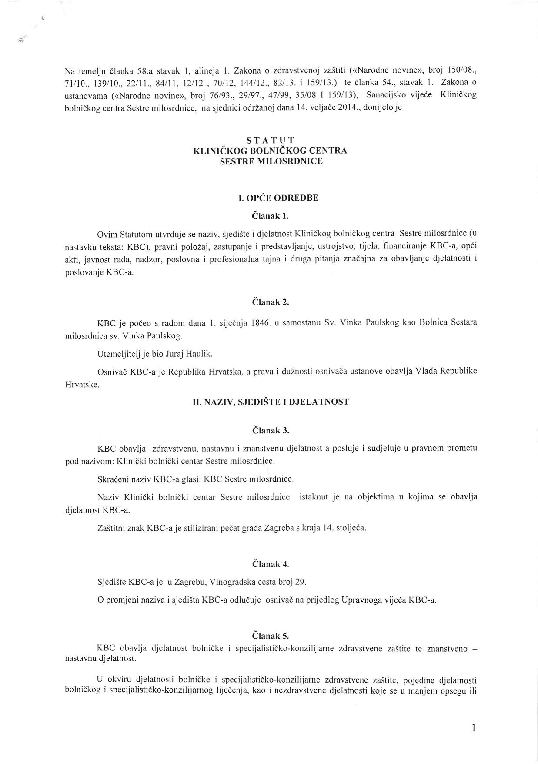

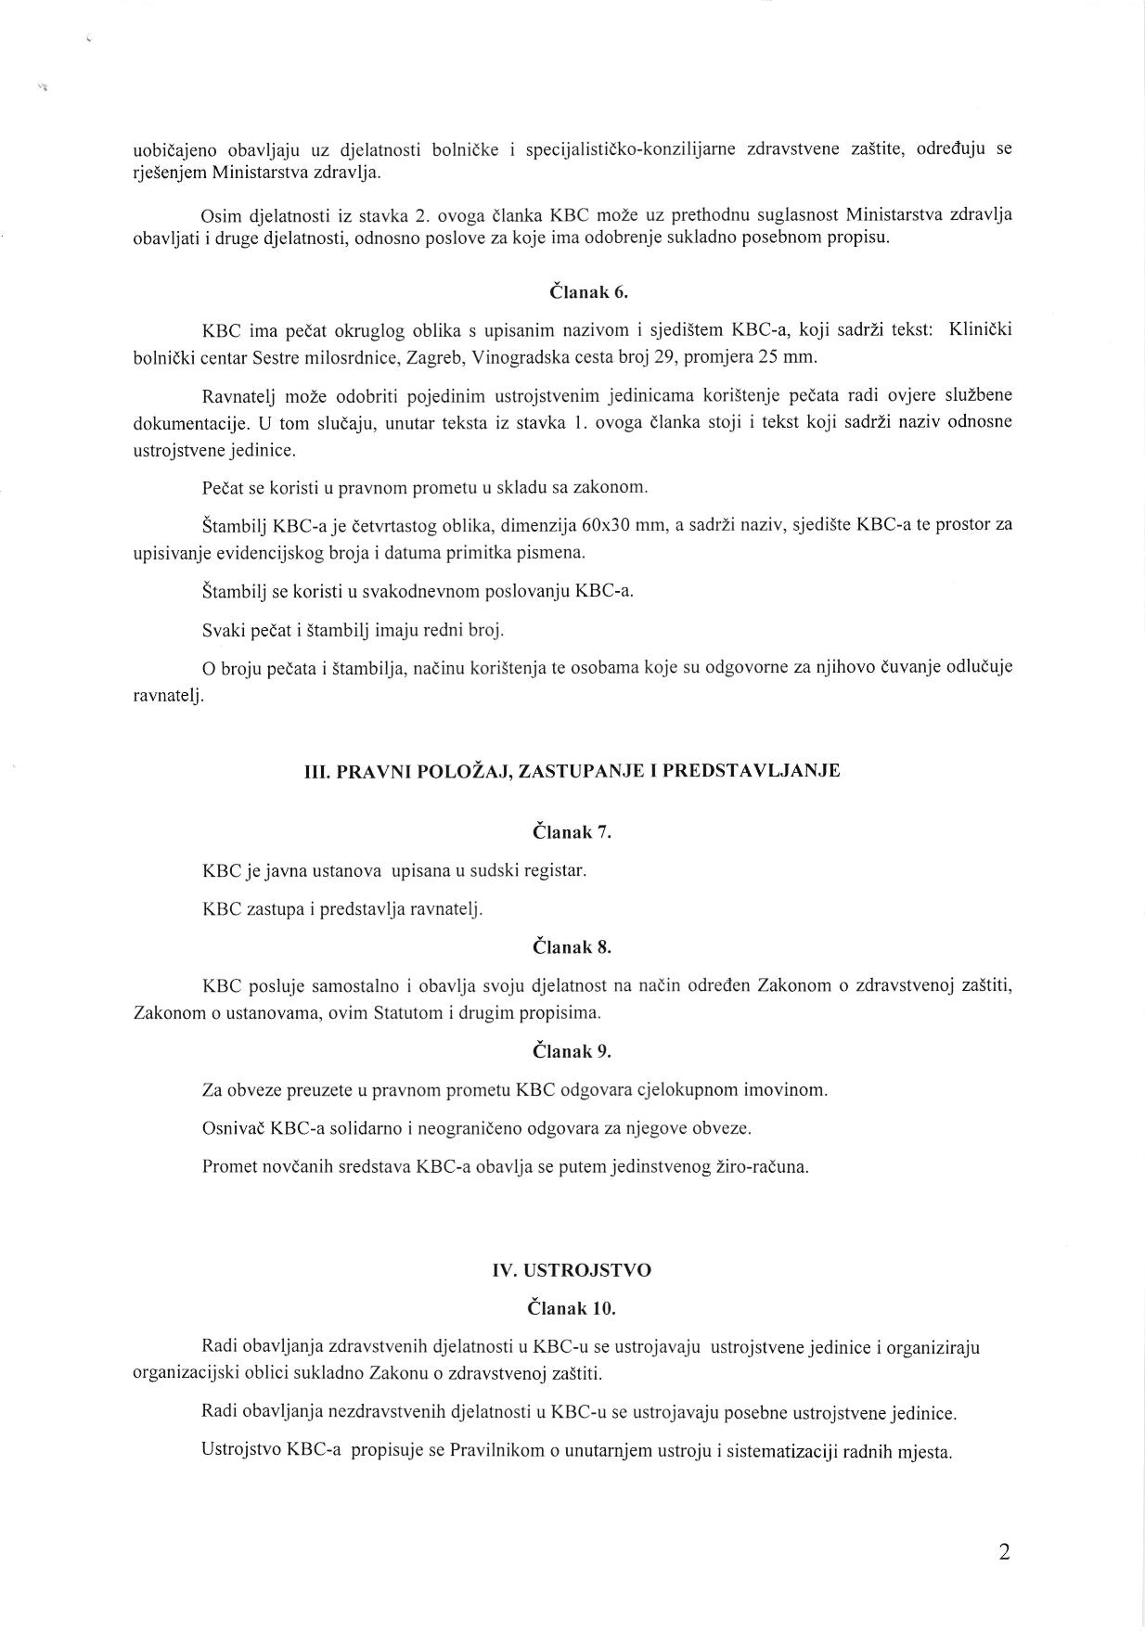

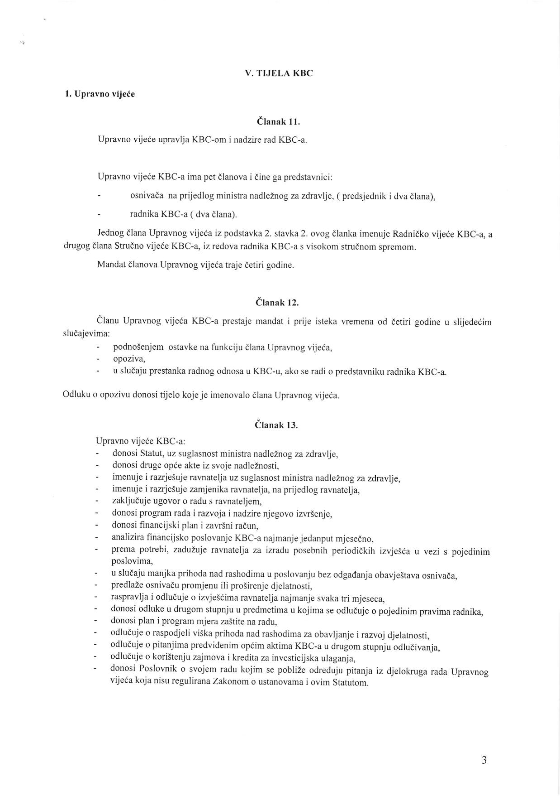

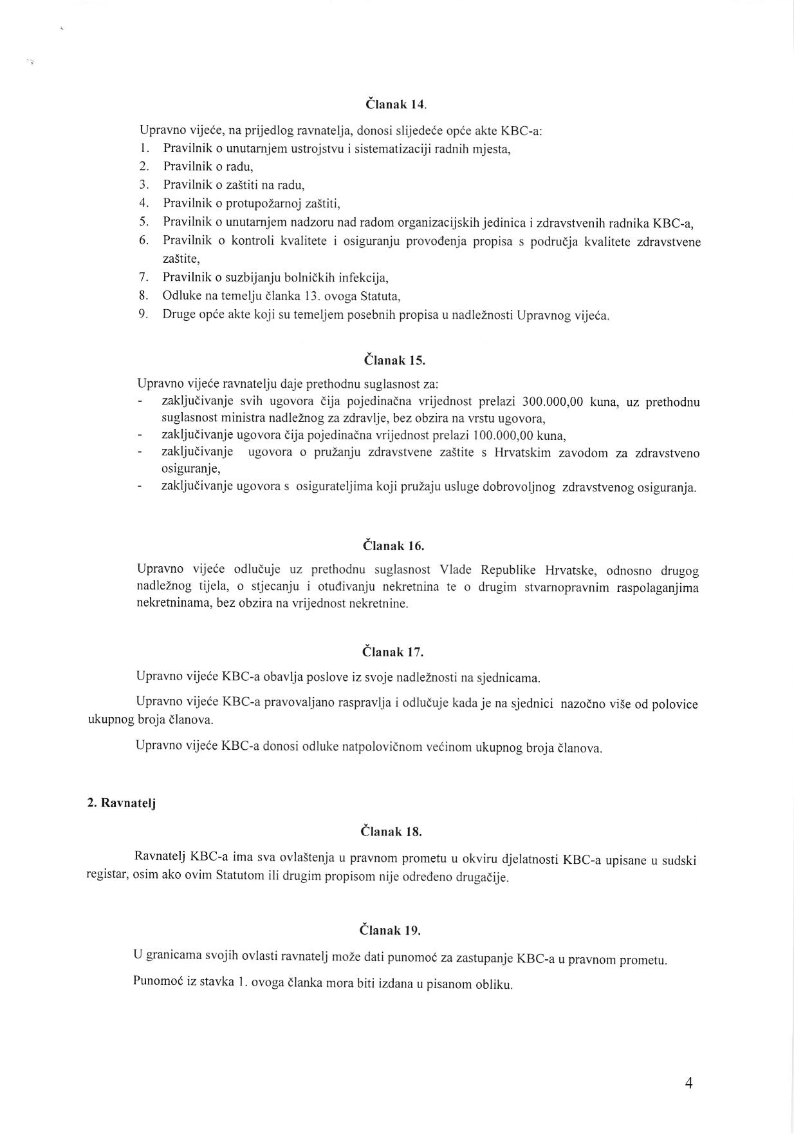

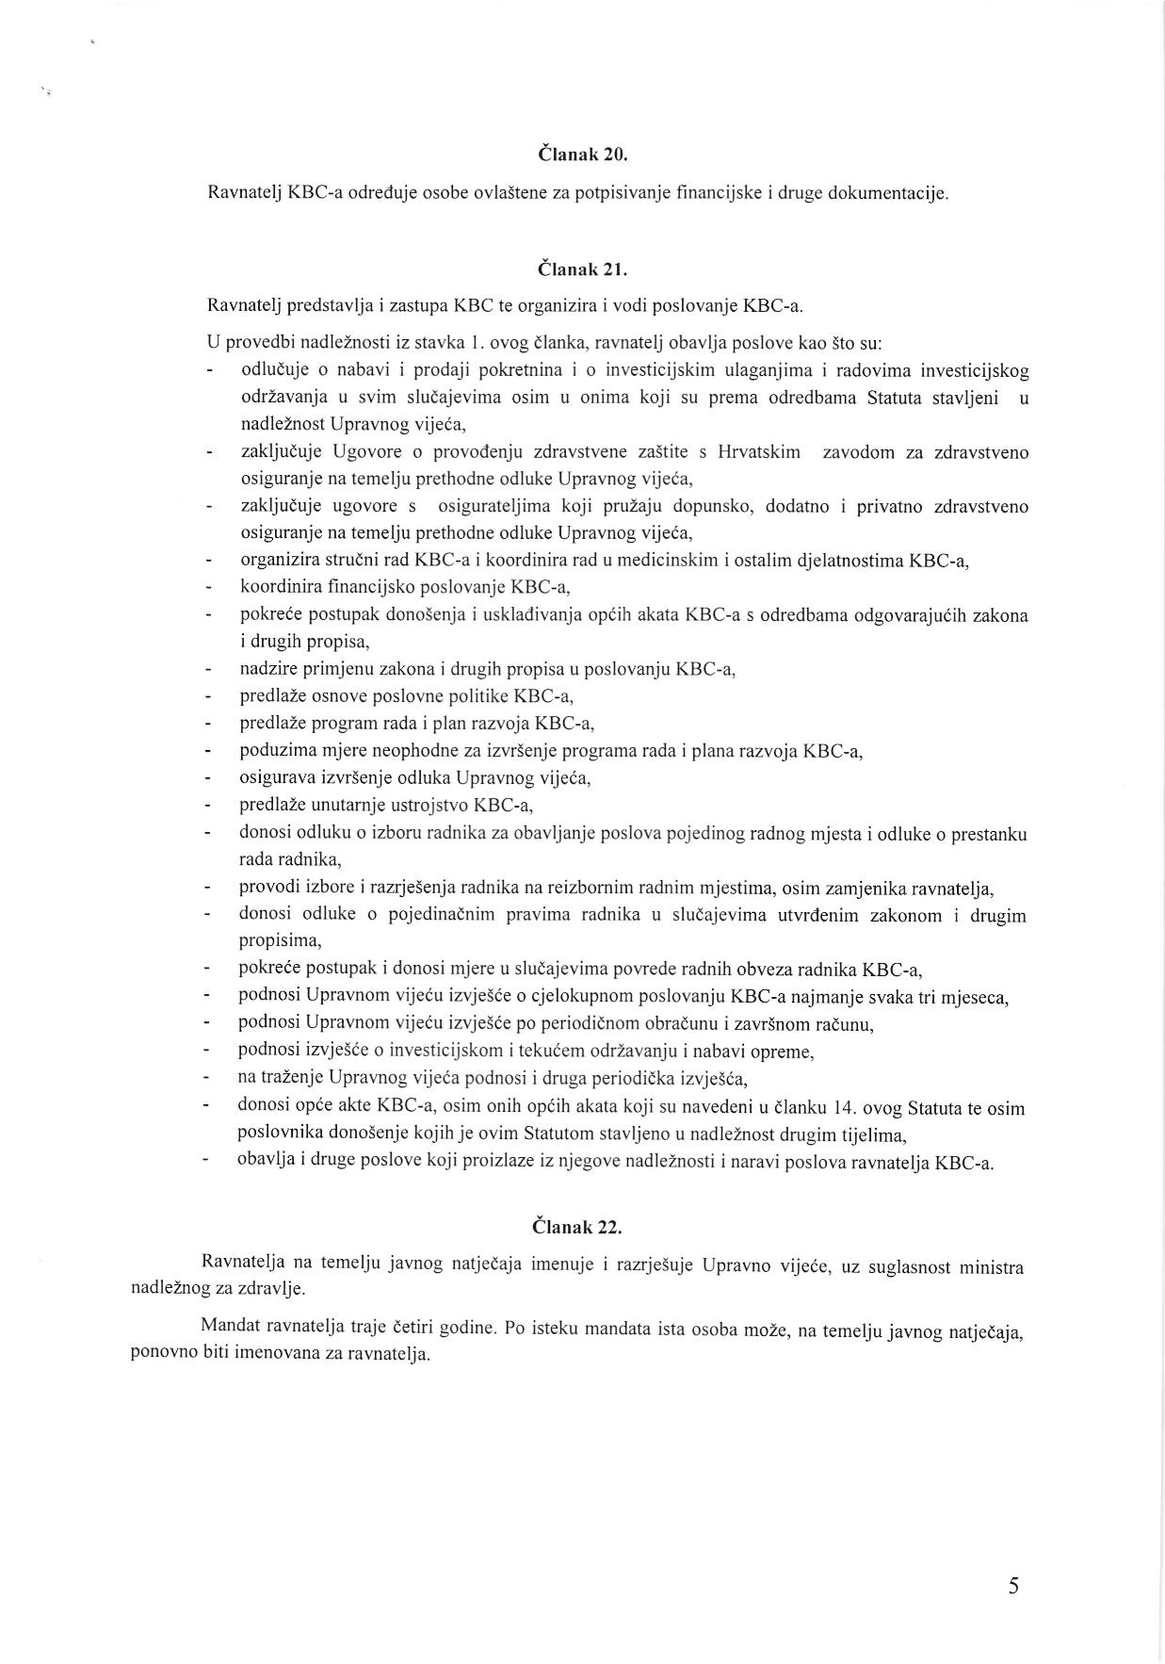

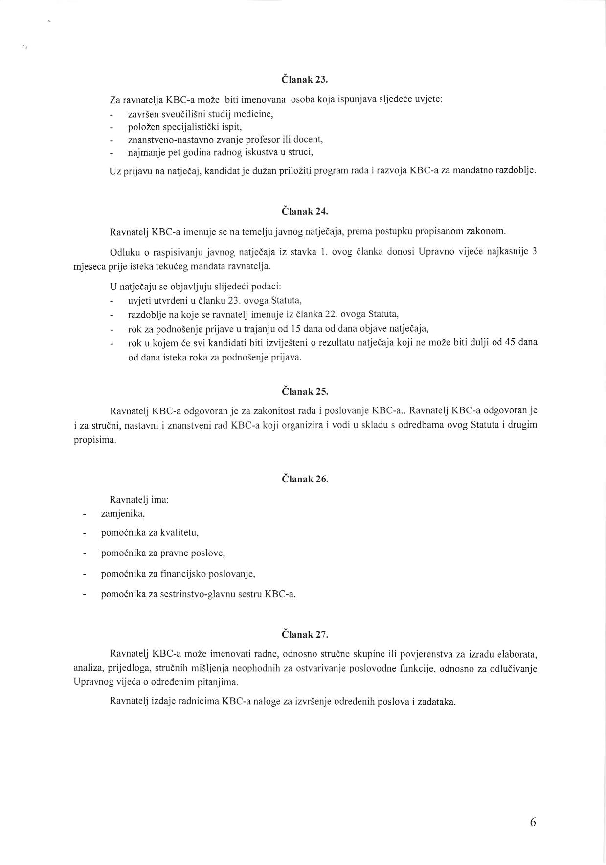

[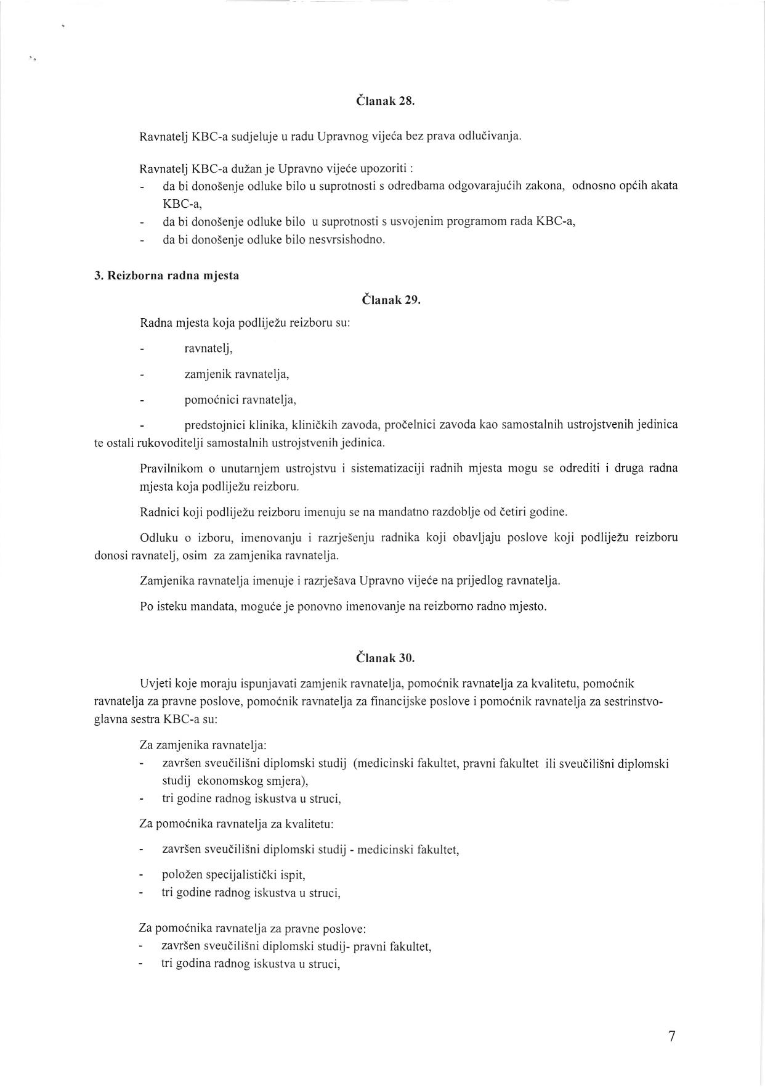](http://www.kbcsm.hr/wp-content/uploads/2015/11/Statut-page-007.jpg)

[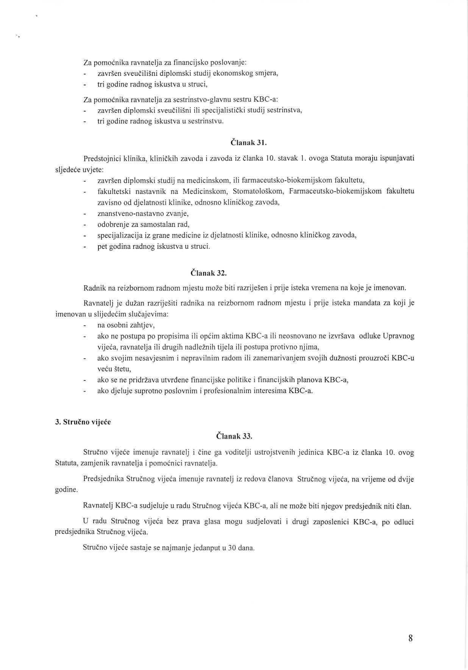](http://www.kbcsm.hr/wp-content/uploads/2015/11/Statut-page-008.jpg)

[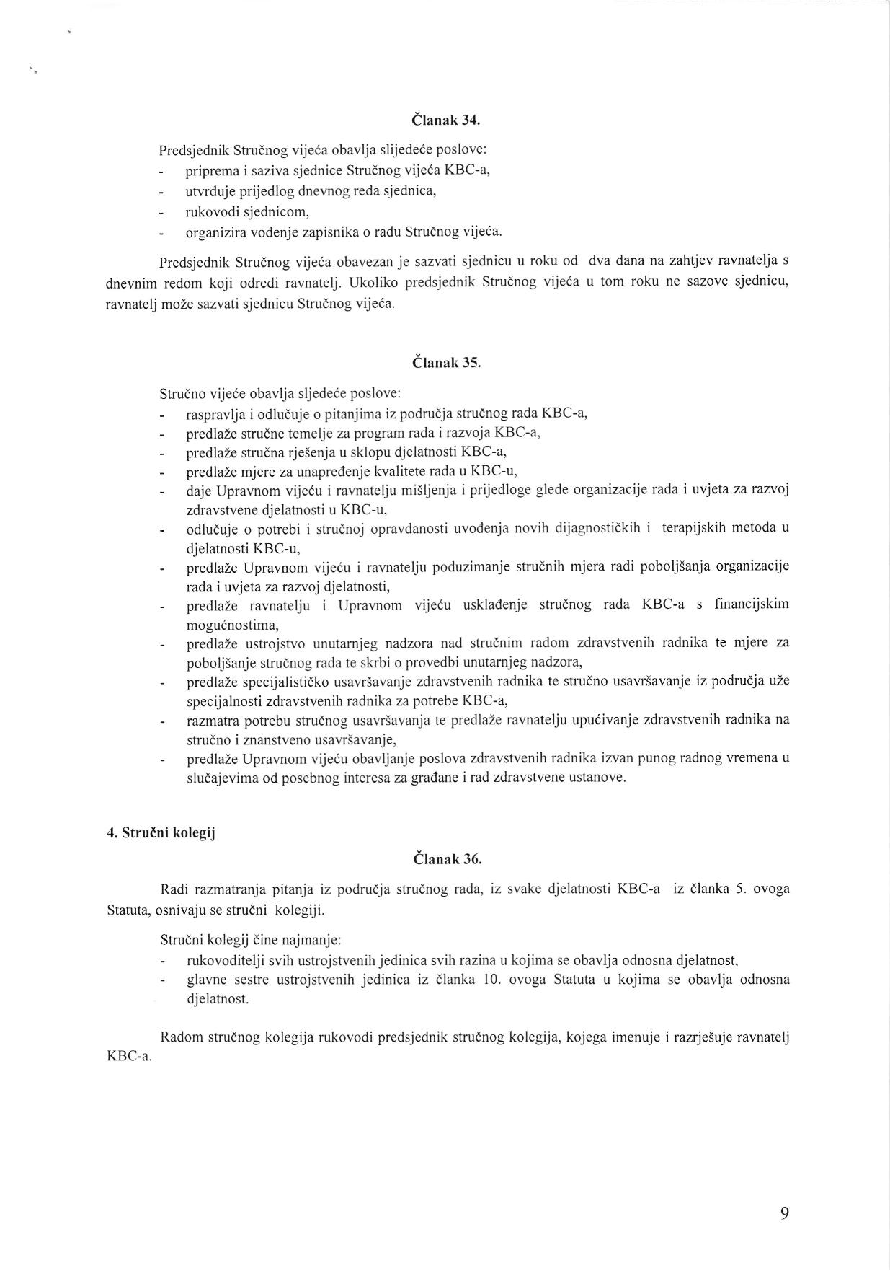](http://www.kbcsm.hr/wp-content/uploads/2015/11/Statut-page-009.jpg)

[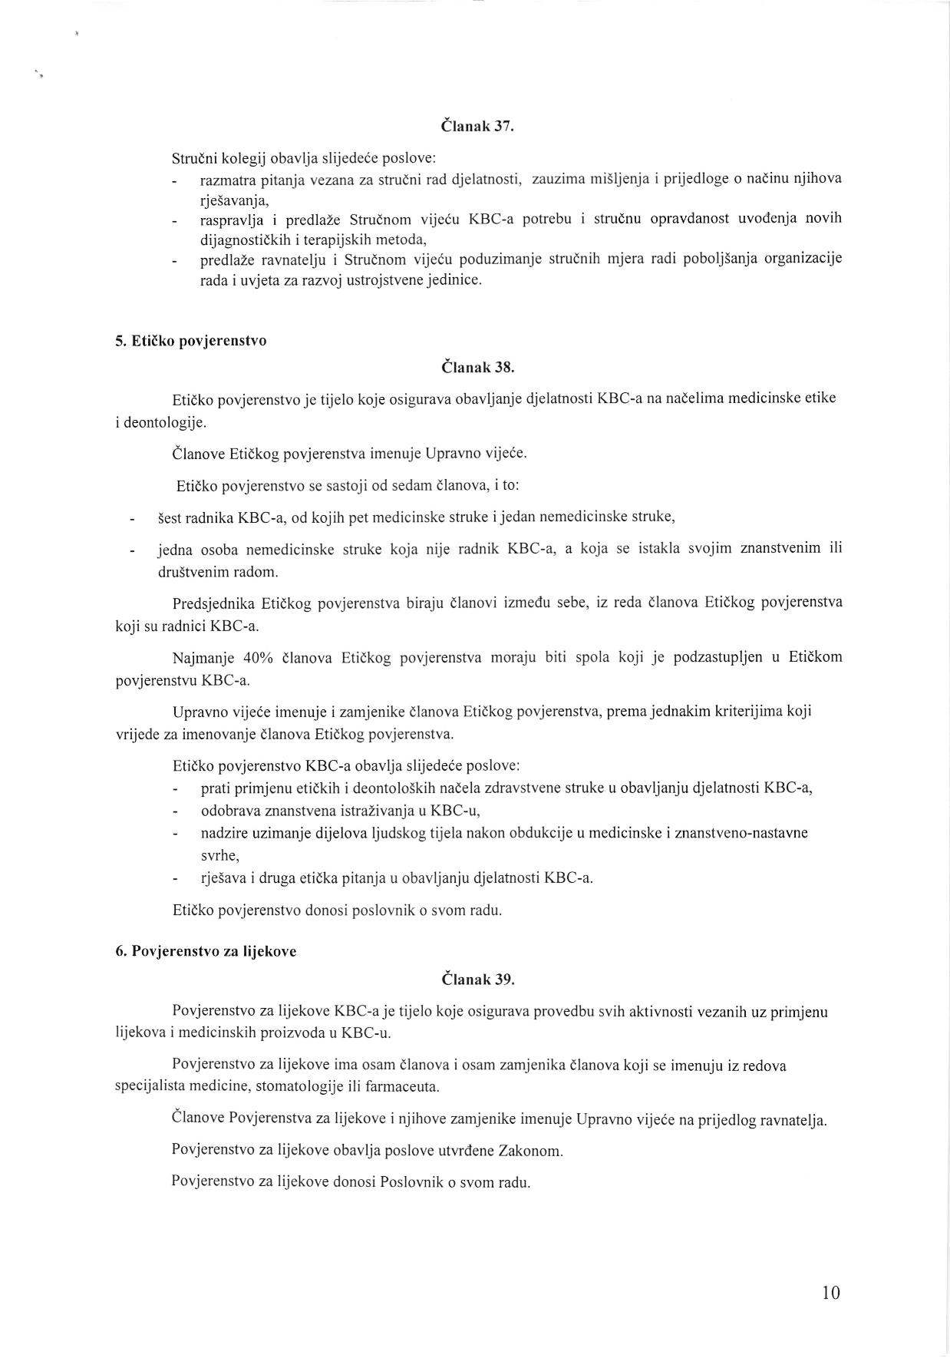](http://www.kbcsm.hr/wp-content/uploads/2015/11/Statut-page-010.jpg)

[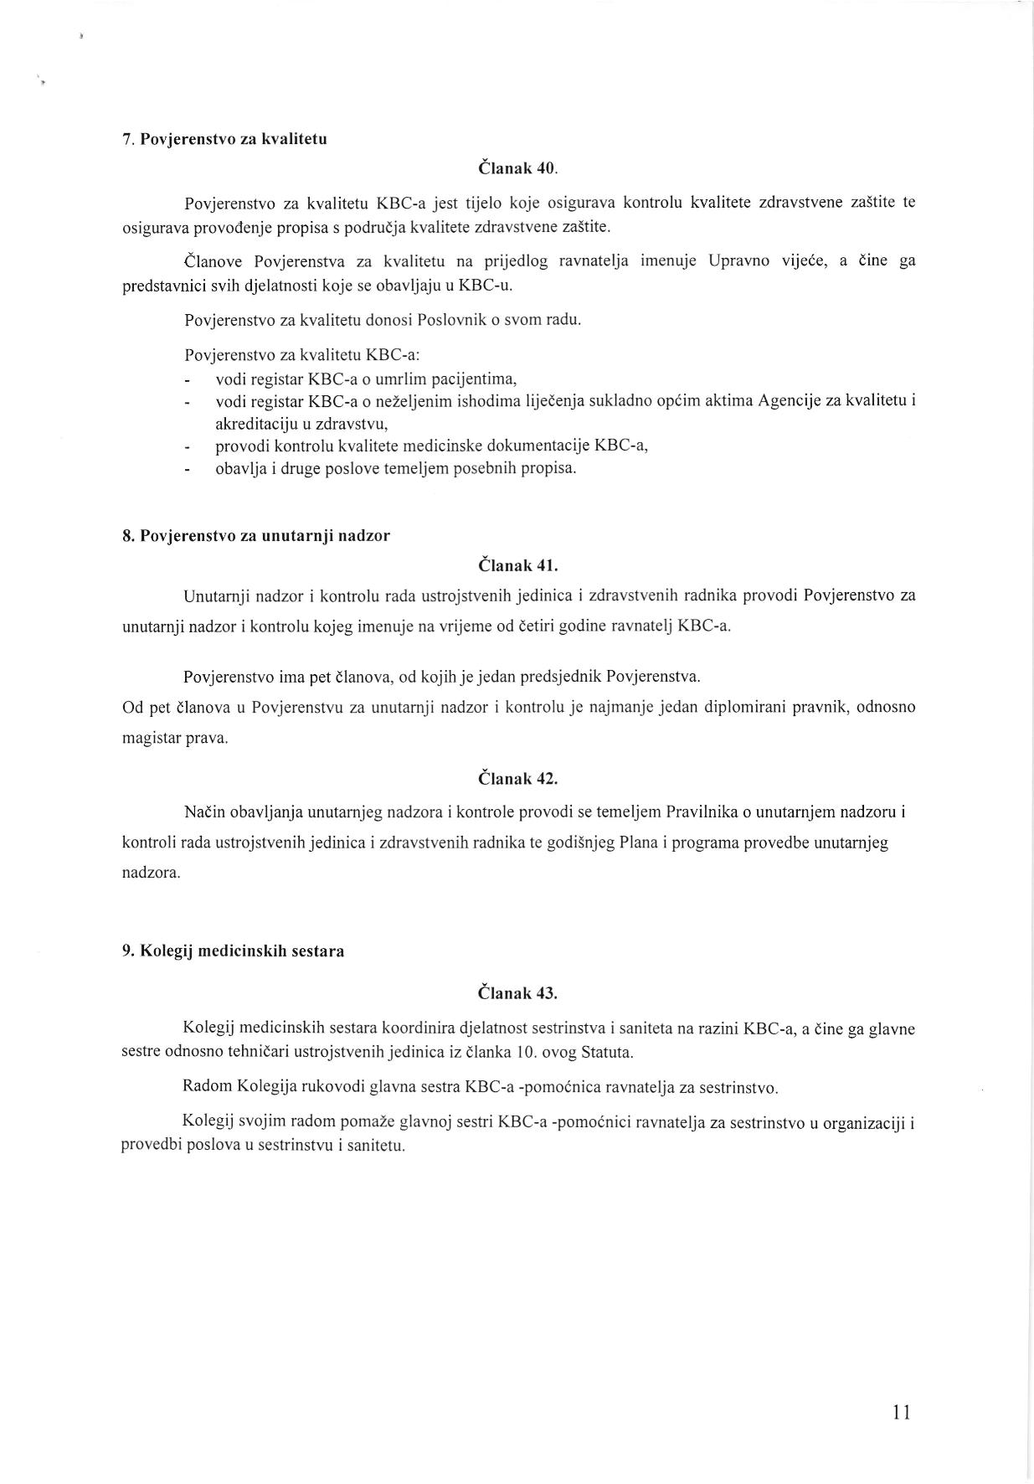](http://www.kbcsm.hr/wp-content/uploads/2015/11/Statut-page-011.jpg)

[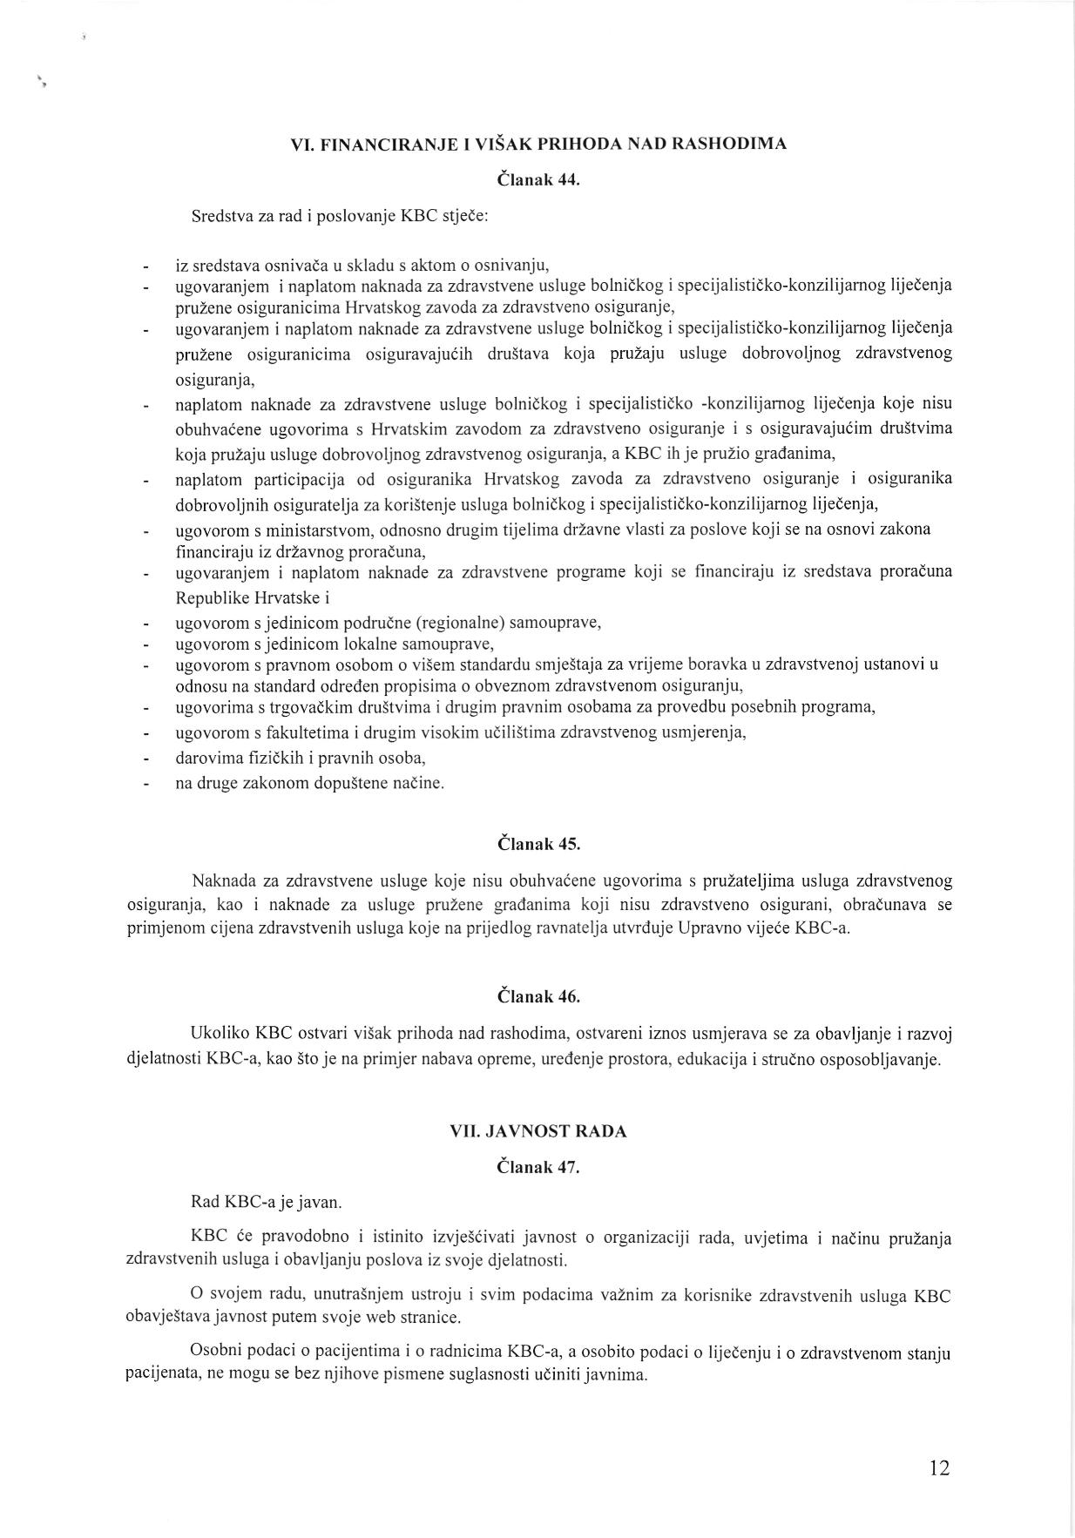](http://www.kbcsm.hr/wp-content/uploads/2015/11/Statut-page-012.jpg)

[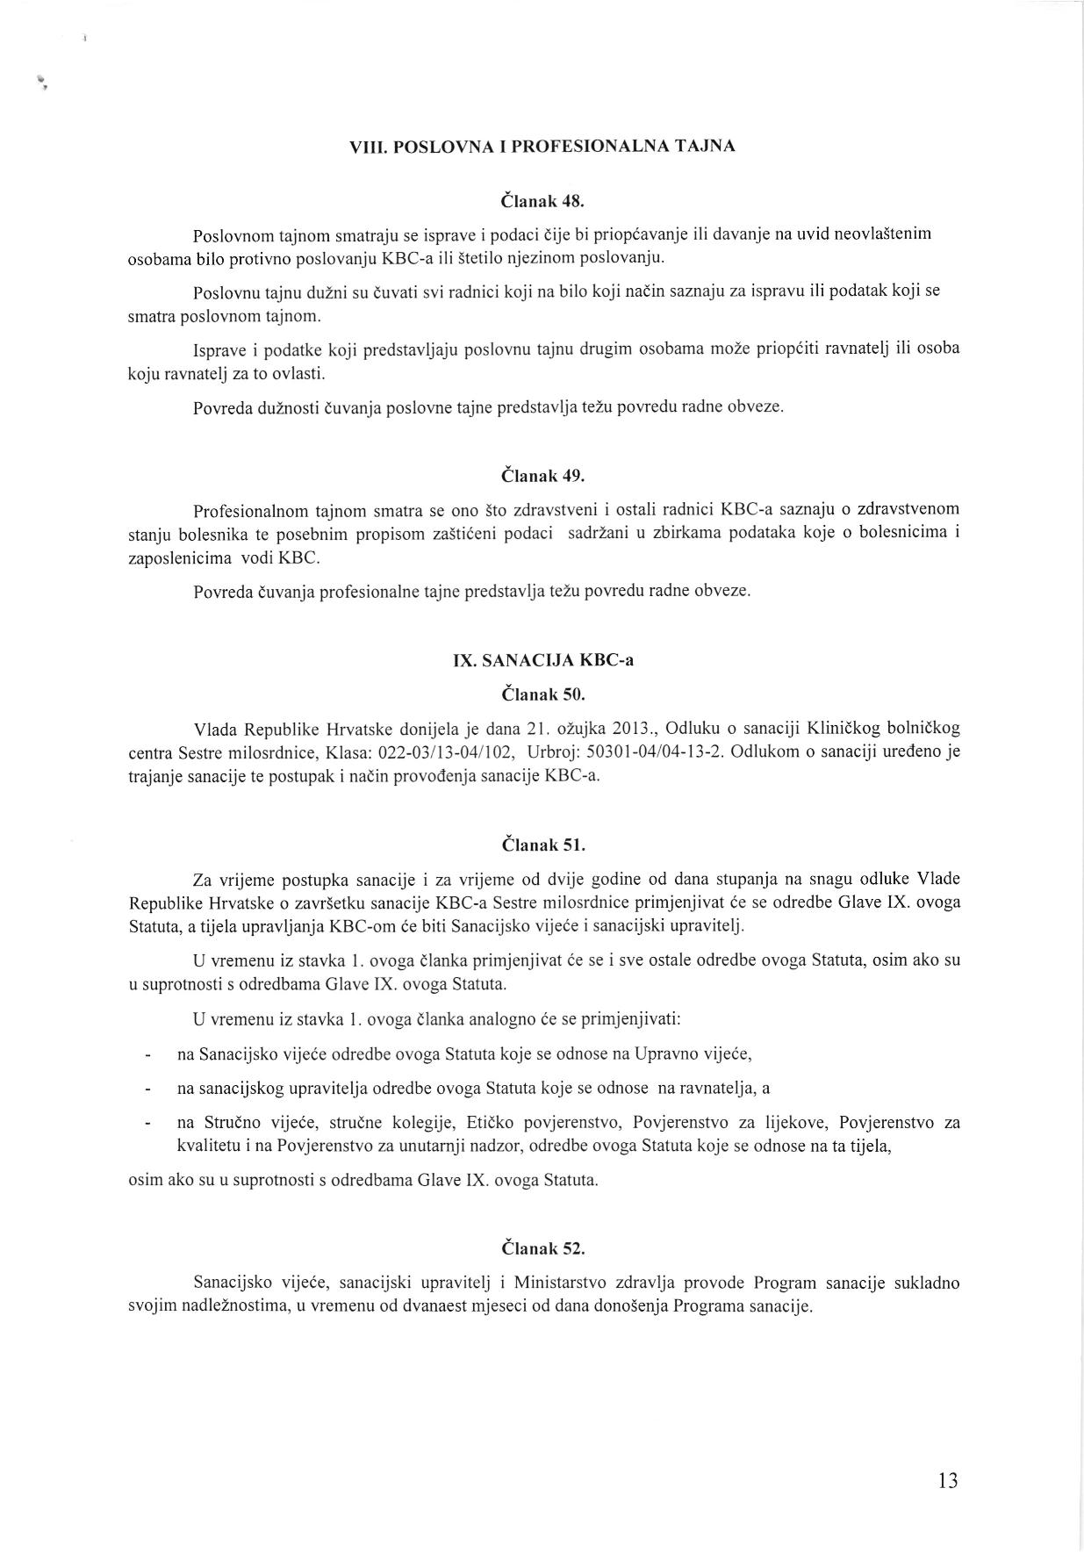](http://www.kbcsm.hr/wp-content/uploads/2015/11/Statut-page-013.jpg)

[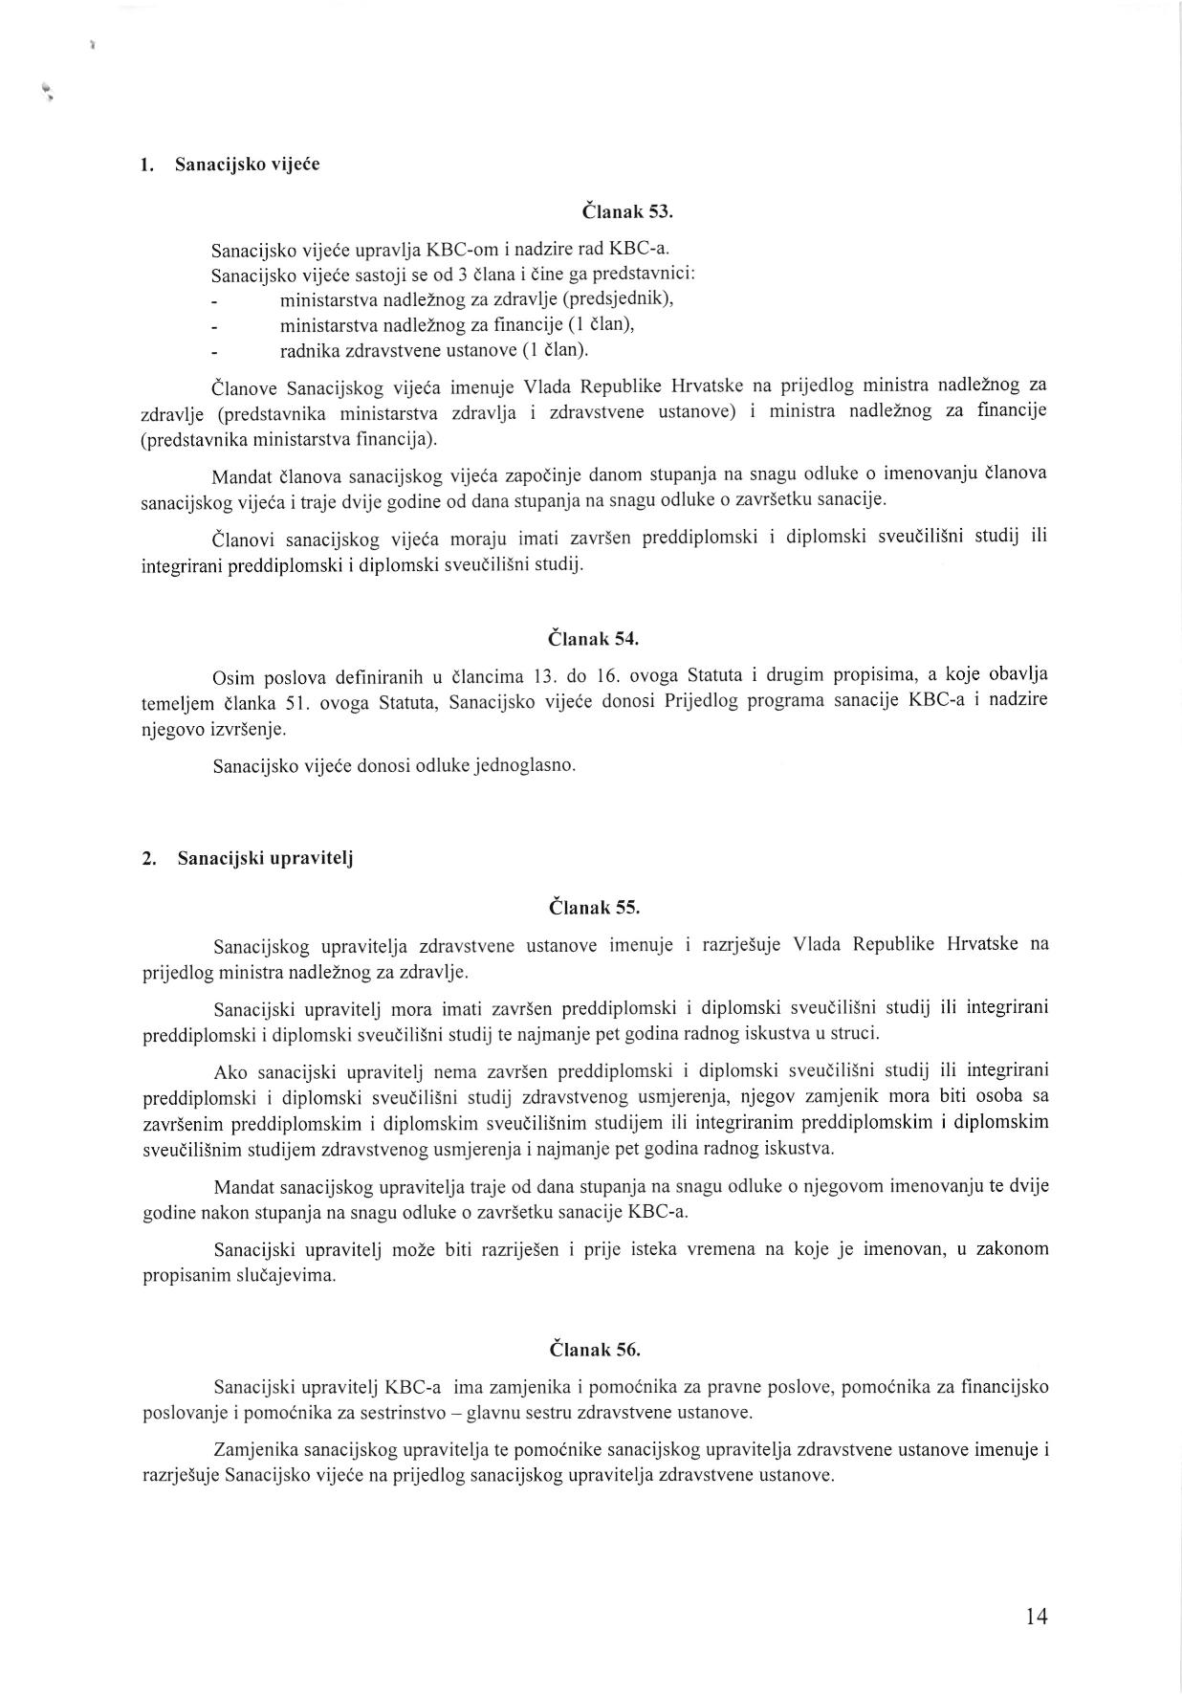](http://www.kbcsm.hr/wp-content/uploads/2015/11/Statut-page-014.jpg)

[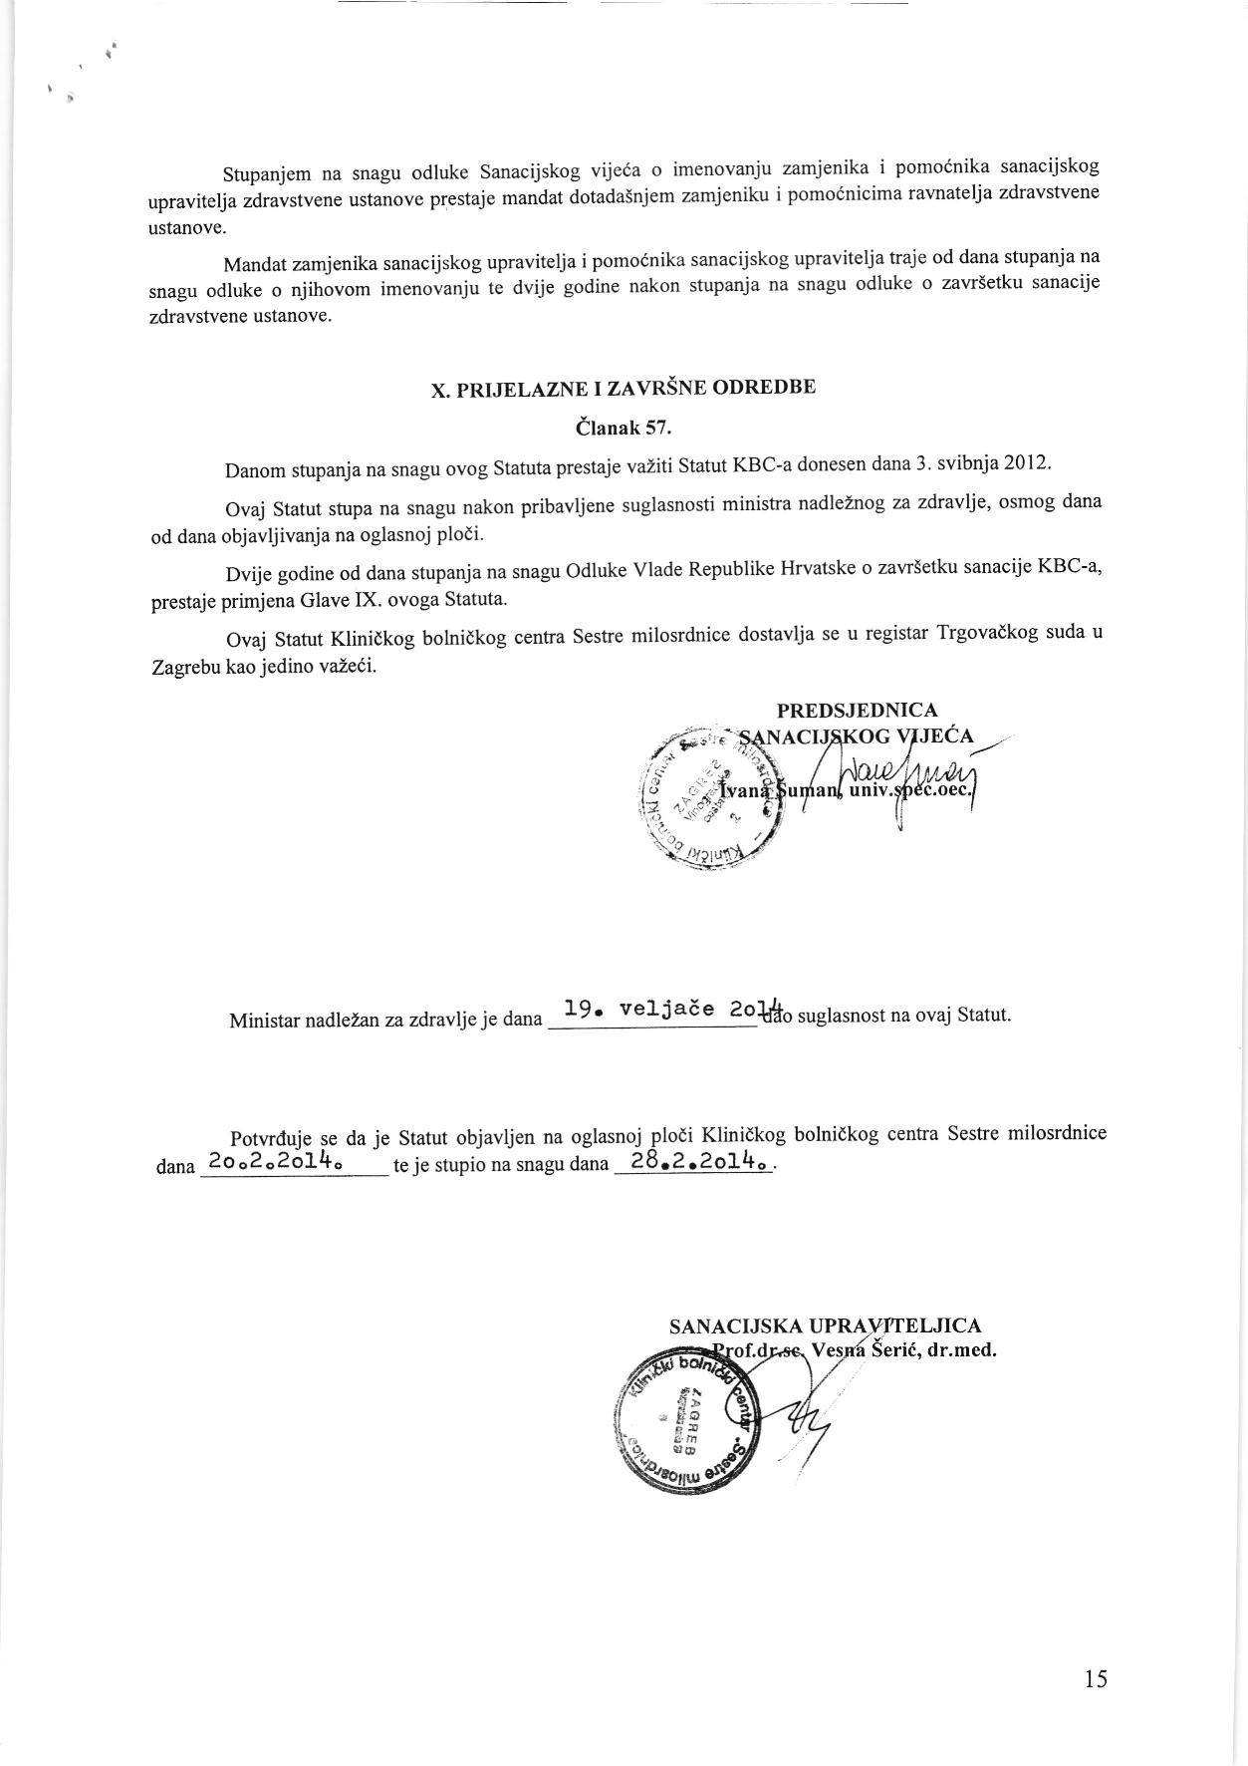](http://www.kbcsm.hr/wp-content/uploads/2015/11/Statut-page-015.jpg)

[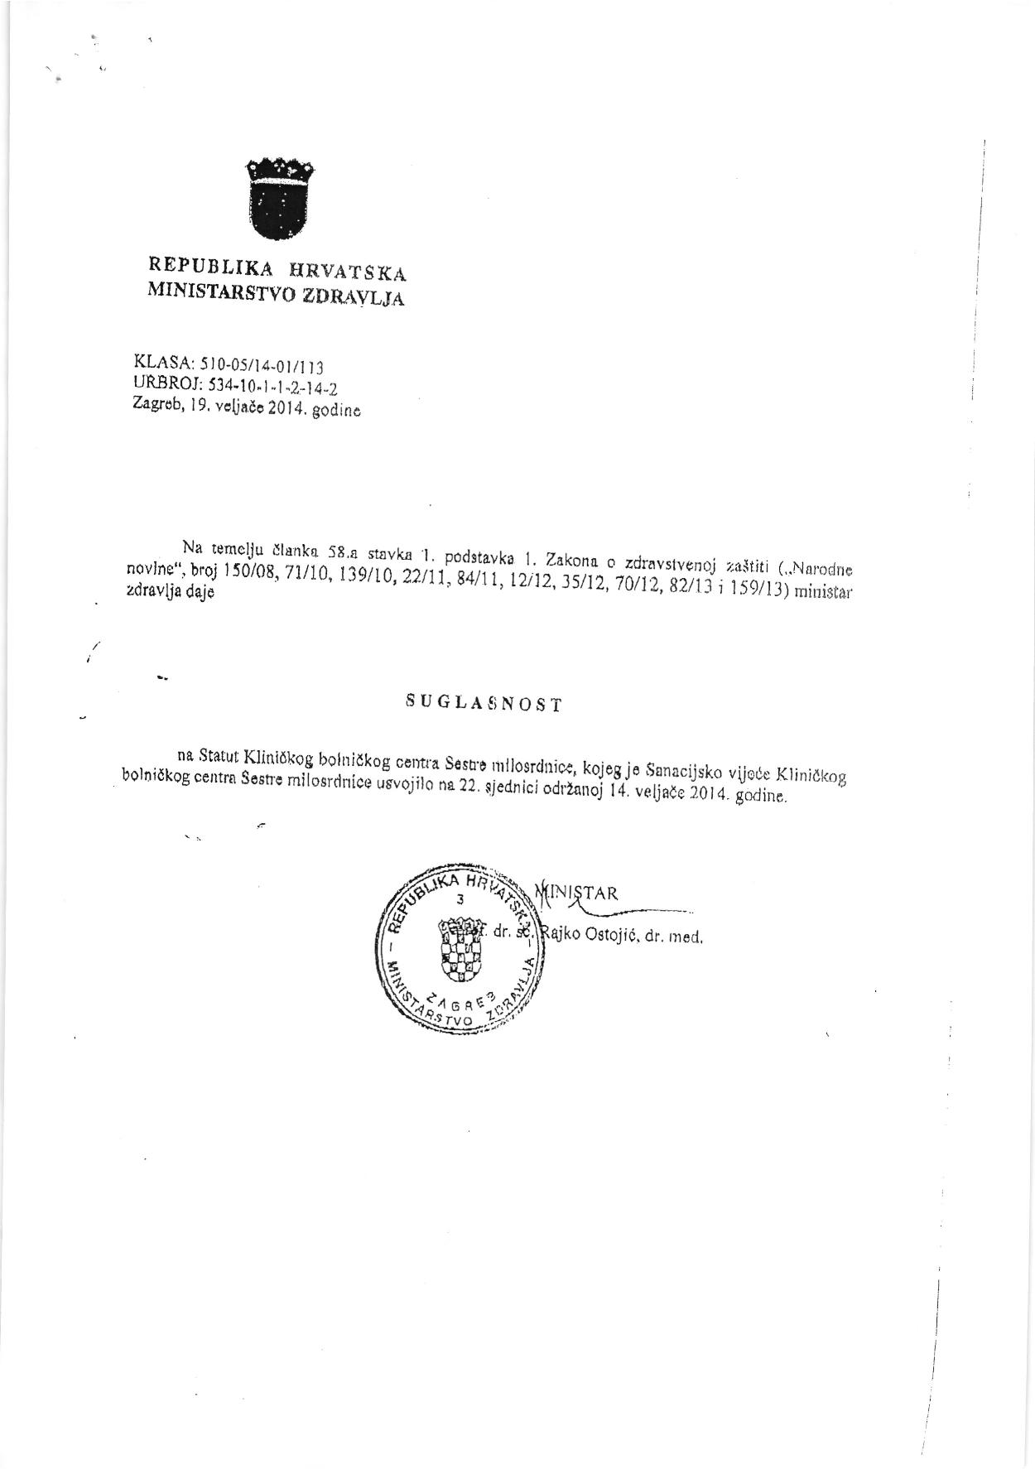](http://www.kbcsm.hr/wp-content/uploads/2015/11/Statut-page-016.jpg)