l

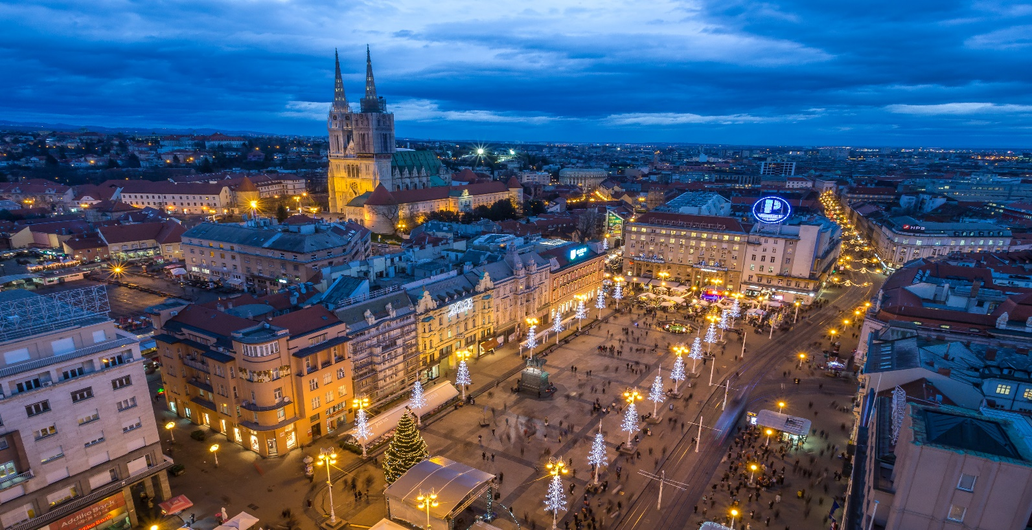



Funded by the Horizon 2020 Framework Programme of the European Union

## **5th COST Action CardioRNA**

## **WG Meeting and**

## **Training School 2020**

**September 7-11 2020.**

**Zagreb,**

**Croatia**

**MEETING VENUE**

University Hospital Centre Sisters of Charity,

Vinogradska street 29, Zagreb

Multimedijska dvorana

**PROGRAM COMMITTEE**

CardioRNA Core Group

Ines Potočnjak, MD, PhD

COST Action CA17129

Catalyzing transcriptomics research in cardiovascular disease

**Chair**

Yvan Devaux (Luxembourg)

**Vice-Chair**

Costanza Emanueli (United Kingdom)

**WG1 Regulatory function of the transcriptome**

Fabio Martelli (Leader, Italy)

Thierry Pedrazzini (Co-leader, Switzerland)

Emma Robinson (Co-leader ECI, The Netherlands)

**WG2 Best practices and experimental standards**

Jan Hellemans (Leader, Belgium)

Fay Betsou (Co-leader, Luxembourg)

David de Gonzalo Calvo (Co-leader ECI, Spain)

**WG3 Development of cohort inventory database**

Monika Stoll (Leader, Germany)

Mehmet Birhan Yilmaz (Co-leader, Turkey)

Bence Ágg (Co-leader ECI, Hungary)

**WG4 Dissemination**

Emma Robinson (Leader, The Netherlands)

Gabriela Kuster (Co-leader, Switzerland)

Ines Potočnjak (Co-leader ECI, Croatia)

**STSM Chair**

Dimitris Beis (Greece)

**ITC Conference Grant Chair**

Irina Carpusca (Luxembourg)

**Science Communication Manager**

Emma Robinson (The Netherlands)

**Grant Manager**

Ines Potočnjak (Croatia)

Meeting venue and time

**Address:** University Hospital Centre Sisters of Charity, Klinički bolnički centar Sestre milosrdnice, Vinogradska street 29, 10 000 Zagreb, **Room:** Multimedijska dvorana

**Monday, 7 September 2020 09:00 - 18:00**

**Tuesday, 8 September 2020 09:00 – 20:00**

**Wednesday, 9 September 2020 08:00 – 21:00**

**Thursday, 10 September 2020 09:00 – 20:00**

**Friday, 11 September 2020 09:00 – 14:30**

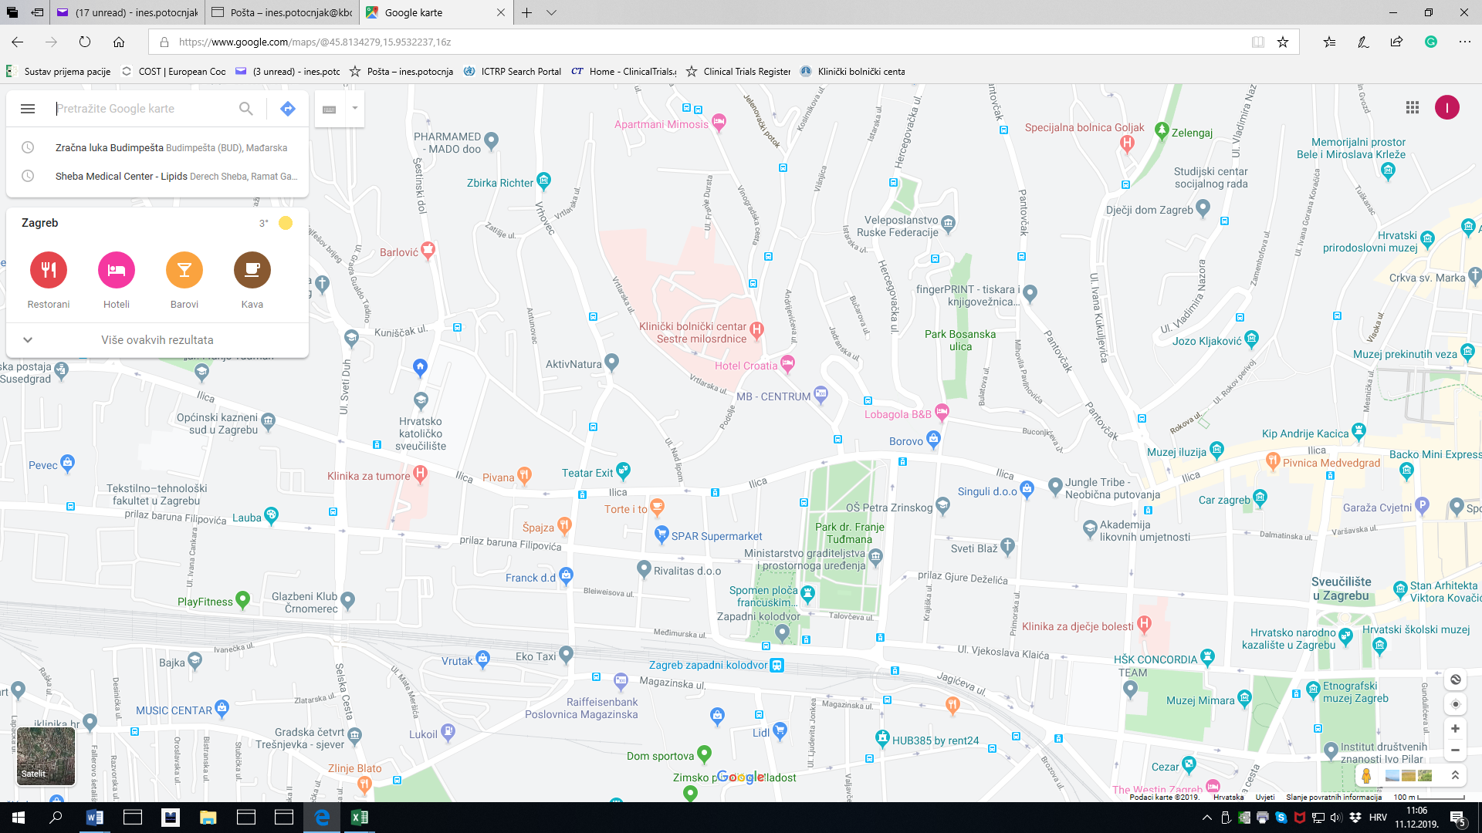

Hotels

**Name Hotel**

Address hotel

Website hotel

Price hotel

How to book room

**Hotels**

**Cover page photo:** "Photography is the property of The Zagreb Tourist Board. Julien Duval is the author of the photo."

Navigation

**From Airport to hotels**

**From Airport to meeting venue**

**From hotels to meeting venue**

**Any other local information**

add picture if available

Local Organizers

**Ines Potočnjak, MD, PhD**

ines.potocnjak@yahoo.com

phone: +385 91 38 20 604

**Prof. Vesna Degoricija, MD, PhD**

Vesna.degoricija@gmail.com

phone:

Administrative support

**Ana Dlaka**

ana.dlaka@kbcsm.hr

phone: +385 1 3787 957

Day 2

Tuesday, 8 September 2020

9:00 - 10:00 WG 2 session with Keynote speaker

10:30-11:00 Coffee Break and Networking

11:00 - 13:00 WG 2 session (Sebastian Albinsson)

13:00-14:00 Lunch

13:00-14:30 WG 2/3 session (Gaia Spinetti, Constantinos Stathopoulos Katja Gehmlich)

15:00-15:30 Break and Networking

15:30 - 16:30 WG 3 session with Keynote speaker

16:30 - 18:00 WG Round tables – 2 tables parallel

18:00-20:00 Poster session and networking event

Day 1

Monday, 7 September 2020

8:00 – 9:00 Core group meeting (Only Core group members invited)

9:00 - 9:30 Opening ceremony Welcome address from prof. Mario Zovak, Director of hospital (All invited)

9:30 - 10:30 Welcome and introductions (Yvan Devaux)

10:30-11:00 Coffee Break and Networking

11:00 -12:30 WG4 session Dissemination update (Emma Robinson)

13:00-14:00 Lunch

13:30-15:00 WG1 session Opening Keynote speaker (Brain heart axis & cell-cell interaction)

15:00-15:30 Break and Networking

15:30 - 17:00 WG 1 session (Prof Dr Timo Brandenburger*, Michele Ciccarelli, Georgios Dedoussis)

17:00 - 18:00 WG 1 round table 1.

18:00 – 20:00 – Poster session

*10min talk + 5 min QA

Day 3

Wednesday, 9 September 2020

8:00 - 8:30 Welcome to the Training School participants

8:30-9:30 How to get Marie Curie grant (Amela Jusić)

9:30 - 10:00 STSM Grant Period 2 Rapid Fire presentations (Dimitris Beis)

10:30-11:00 Coffee Break and Networking

10:30 - 11:30 ITC Conference grant awardees and poster presenters’ winners (Irina Carpusca, Fabiana Martino)

11:30 - 12:00 Future plans for meeting in Greece (Dimitris Beis)

12:00 - 12:30 Closing Remarks for WG meeting

13:00-14:00 Lunch

14:15 - 21:00 Social event for WG AND TS

Day 4

Thursday, 10 September 2020

09:00-10:00 Introdution

10:30-11:00 Coffee Break and Networking

10:30-12:00 Session 1 with Invited trainer (David Montgomery)

13:00-14:00 Lunch

13:00-14:30 Session 2 with Invited trainer - communication of scientific results

15:00-15:30 Break and Networking

15:30 - 16:30 Training School participants Fire presentations

16:30 - 18:00 Session 3 (Costanza Emanueli)

18:00 - 20:00 Networking event

Day 5

Friday, 11 September 2020

09:00-10:00 Session 4

10:30-11:00 Coffee Break and Networking

10:30-12:00 Session 5

12:00-13:00 Plans for the future

13:00-14:00 Lunch and leave